Order Of Service

Opening Hymn: TLH 140

Reading: Lent I

The History of the Passion of our Lord

Sermon Hymn: TLH 142

Sermon Text: Luke 20:1-8

Two Questions

Confession of Sins: O almighty God, merciful Father, I, a poor miserable sinner, confess unto Thee all my sins and iniquities, with which I have ever offended Thee and justly deserved Thy temporal and eternal punishment. But I am heartily sorry for them and sincerely repent of them, and I pray Thee of Thy boundless mercy and for the sake of the holy, innocent, bitter sufferings and death of Thy beloved Son, Jesus Christ, to be gracious and merciful to me, a poor, sinful being.

Holy Communion

The Lord's Prayer

The Blessing

Closing Hymn: TLH 147

* * * * * * * * * * * * *

Bible Study: Lambs: TBA
Sheep: Deuteronomy 1:37-46
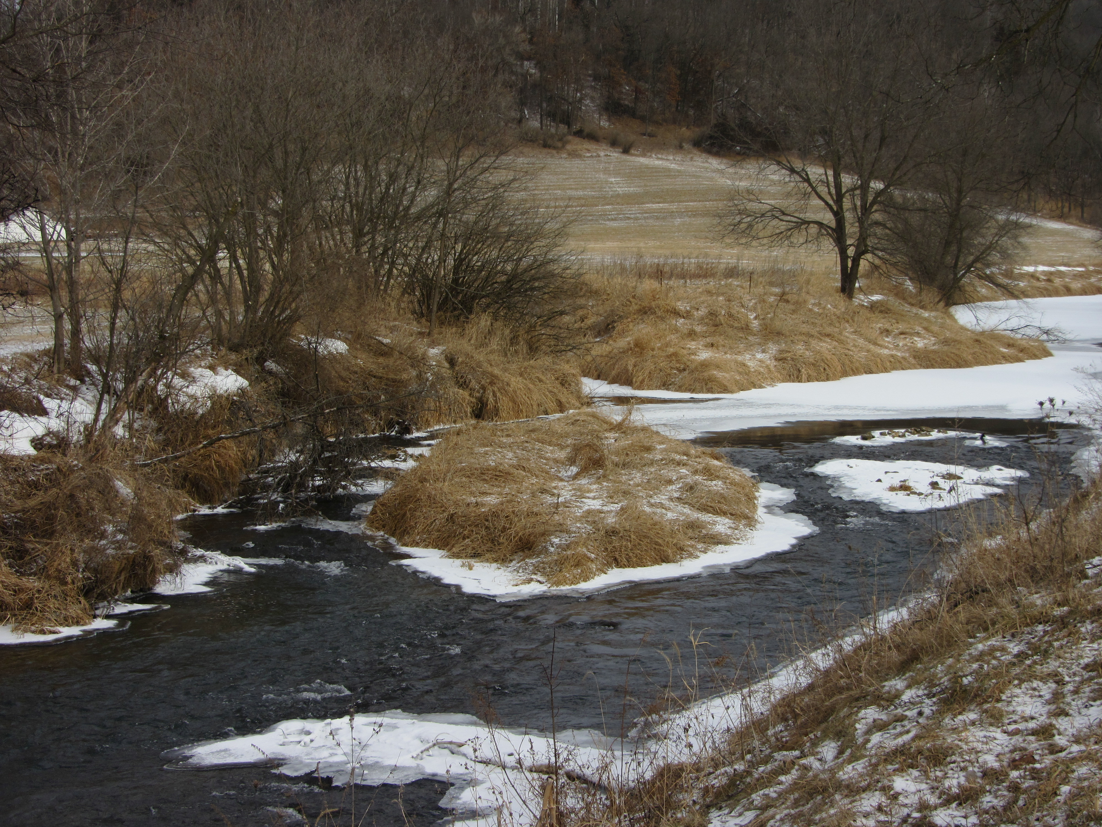

Open Water

Water
Of
Life

19 February 2023

W A T E R O F L I F E

Independent Christian Church—Conservative Lutheran Doctrine

Worship Service: 9:30 a.m. Bible Study: 10:45 a.m.

Larry Cooper, Pastor E-Mail address:
111 N. Ridge Road lcooper@wateroflife.cc
Coon Valley, WI 54623 Web Site:
www.wateroflife.cc

* * * * * * * * * * * * * * * * * * * * * * * * * * *

Sermon Text: Luke 20:1-8

Two Questions

* * * * * * * * * * * * * * * * * * * * * * * * * * *

1 And it came to pass, that on one of those days, as he taught the people in the temple, and preached the gospel, the chief priests and the scribes came upon him with the elders,
2 And spake unto him, saying, Tell us, by what authority doest thou these things? or who is he that gave thee this authority?
3 And he answered and said unto them, I will also ask you one thing; and answer me:
4 The baptism of John, was it from heaven, or of men?
5 And they reasoned with themselves, saying, If we shall say, From heaven; he will say, Why then believed ye him not?
6 But and if we say, Of men; all the people will stone us: for they be persuaded that John was a prophet.
7 And they answered, that they could not tell whence it was.
8 And Jesus said unto them, Neither tell I you by what authority I do these things.

